**9.USING RAPTOR – CHECK GIVEN NUMBER PRIME OR NOT**

**Y.NAVEEN KUMAR REDDY**

**192111405**

**FLOWCHART:**

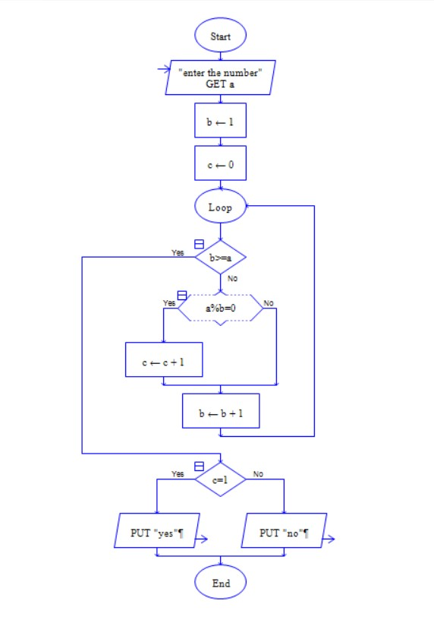

**OUTPUT:**

INPUT: 23

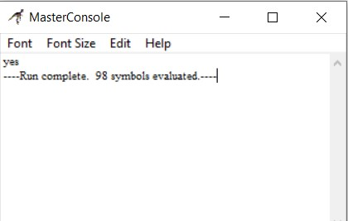

**RESULT:**

The program is executed and verified successfully.